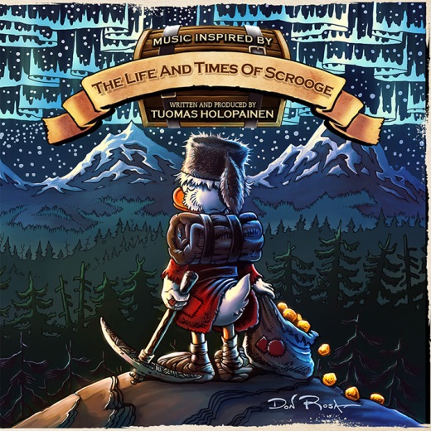

TUOMAS HOLOPAINEN »The Life And Times Of Scrooge«

OUT: April 11, 2014

Tuomas Holopainen online:
www.tuomas-holopainen.com
www.facebook.com/tuomas.l.j.holopainen
www.nuclearblast.de/tuomas-holopainen

Tuomas Holopainen – the keyboardist and main songwriter of NIGHTWISH - has spent most of the year 2013 writing and producing his solo album. The whole album will be based on a graphic novel called »The Life And Times Of Scrooge McDuck«, written and illustrated by Don Rosa.

Tuomas Holopainen comments: “This is my longtime dream come true, 14 years in the making. And a homage to one of the best storytellers of our time. Thank you for sharing this celebration of Life & Adventure!”

This 12 - chapter book tells the life story of a certain Scrooge, from his early years in the 19th century Scotland to his adventures all around the world until the 1950`s. The story contains such immense depth, detail, wit and emotional power, that the moment Tuomas read it nearly 20 years ago, it instantly became a story of profound personal interest and love for him. The initial spark of `coloring` this story with music, i.e. create a kind of "soundtrack" for the book, came to him already in 1999, and has ever since been haunting the back of his mind.

The album was written and produced by Tuomas Holopainen and will contain 10 songs, with total duration of approximately 60 minutes. The music will be of soundtrack / classical / folk genre in the vein of Vaughan Williams, Michael Nyman, James Newton Howard and Enya.

Mr. Pip Williams has done the orchestral arrangements, continuing his collaboration with Tuomas after the NIGHTWISH records »Once«, »Dark Passion Play« & »Imaginaerum«.

There will be a number of guest musicians, including the London Orchestra, The Metro Voices (a choir from London) and four lead vocalists: Alan Reid, Johanna Kurkela, Johanna Iivanainen & Tony Kakko. Other guest appearances include Troy Donockley (uilleann pipes, low whistles, bodhran), Mikko Iivanainen (guitars & banjo), Teho Majamäki (Didgeridoo), Jon Burr (Harmonica) and Dermot Crehan in the solo violin.
The recordings took place during August - October 2013, first at Angel Studios, London, then in various locations around Scotland and Finland.

The author of the book, Don Rosa, has done the artwork for the album.

© Nuclear Blast

